WEEK 7: EXPERIMENT WITH DIFFERENT LAYOUTS AND COLOR SCHEMES FOR AN APP. COLLECT USER FEEDBACK ON AESTHETICS AND USABILITY USING GIMP(GNU IMAGE MANIPULATION PROGRAM (GIMP)
V Roshini | 230701270 | CSE-FC

AIM: The aim is to trial different app layouts and colour schemes and evaluate user feedback on aesthetics and usability using GIMP.
1. Design the Layout
So these are the three designs of login page I created for a online movie ticket booking app.
Design 1 is the simplest layout created that to just using the basic elements and no fancy decors are done in that. Here we just have the basic requirements such as email and password. And on top it says what page it is (login page) and the cinema app name (EVP Cinemas).
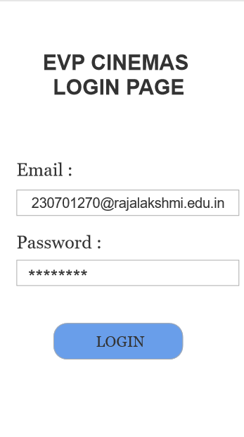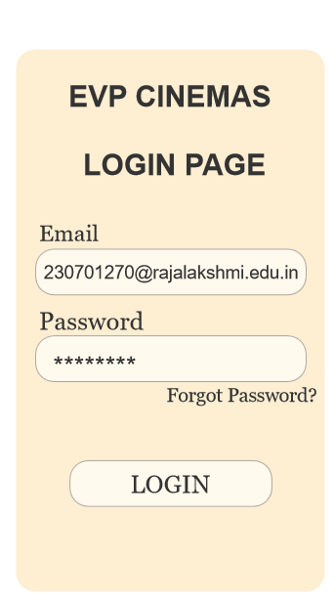
Design 1 Design 2
Design 2 is a bit developed layout where we have incorporated the subtle colours and also added new feature of “Forgot Password”. This feature is used when a user is trying to login to the app and they are unable to recall the password, then they can use this forgot password option and reset their old password.

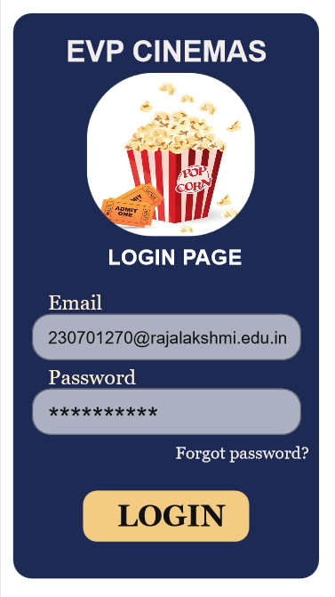
Design 3

At last we have Design 3 which was further developed from Design 2. Here we have focused on the colour theme which will be suitable for movie theatres and we also have included a image on top which visualizes and gives us the feel of watching a movie and attracts the users attention. Design 3 gives a casual yet professional look as well.

2. Collect User Feedback
I prepared a small survey in real time a asked multiple users about the usability, aesthetics and about the colour of each layout and this was their response.
I had provided all three designs to multiple users and asked for their review on these designs and their preference among these three designs.
Majority of them have said that design 1 is very basic and doesn’t contain any elements at all and is not very pleasing to their eyes. And None of them have voted for Desing 1.
Few members have voted for Design 2 and liked it a bit in both usability and colour wise.
Literally All of the users liked the Design 3 and have voted for it and they really enjoyed the Design 3 and gave a positive review that it is the best design among these three layouts and would love to use this design.

Therefore, we can say that Design 3 is the best design among these three layouts and this can be implemented in real life scenario.

